DAILY ASSESSMENT FORMAT

|  |  |  |  |
| --- | --- | --- | --- |
| Date: | 18-05-2020 | Name: | Preetham s rai |
| Course: | ECE | USN: | 4AL18EC040 |
| Topic: | 1.Communicate to express  2.Deliver presentation with impact  3.Develop soft skills for workplace | Semester & Section: | 4th sem A-sec |
| Github  Repository: | Psraipreetham |  |  |

|  |  |
| --- | --- |
|  | FORENOON SESSION DETAILS |
| Image of session:  In this session I learnt about  Communication skills,  How to create good presentation. |  |

|  |
| --- |
|  |
| Report :  DAY-1  It is a good course in these lockdown time to learn something. As we know how important hard skills and soft skills in our daily life.Through career edge we henace and sharpe our personality and knowledge.  Today session is much helpful for improve skills to understand what communication is and why we communicate. Some important topics are, Importance of communication  Communication: Communication is an act of sending information of sending information from one Person to another.  Why should we communicate?   * Give information : e.g. two people talking to each other or news from the newspaper/radio. * Persuade: e.g. to sell a product or convince a person. * Express need: e.g. when you are hungry or need a report for the meeting. * Form social bonds: e.g. greeting others or introducing yourself. * Share feelings: e.g. share your happiness or sorrow.     Types of communication   * Verbal: * Non verbal * Visual * Written     Process of communication |

Basic things to communicate is

Sender ,encoder, channel, decoder and rece

iver.

There is some barriers over communication.

They are may be physical, cultural, gender, psychological, language and perceptual.

Physical barrier like separation between people, and distance, or noice or time.

Cultural barriers like

interacting with people from other countries has its own barrier like greeting,

stereotyping and behavior.

DAY

-

2

In this session what I learnt is:

Design effective PPTs.

Make an effective presentation.

Follow the Do’s and don’ts in ppt skils.

Befor

e creating a presentation we have to go through these 5 W’s

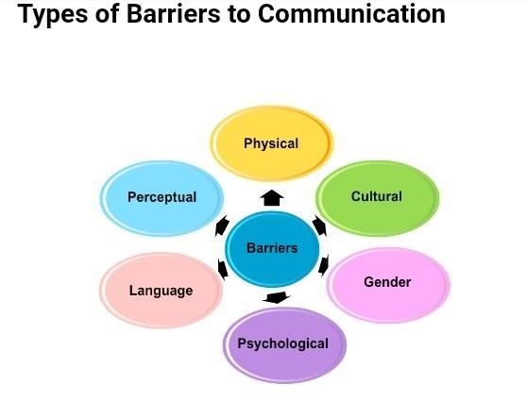

Fewer words

•

Use a single word or sentence and then elaborate as you present.

•

Look at the example to understand better.

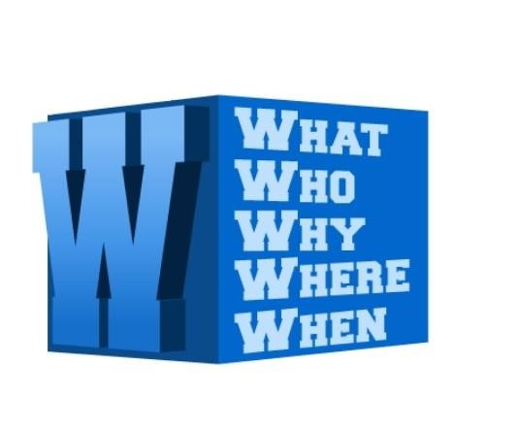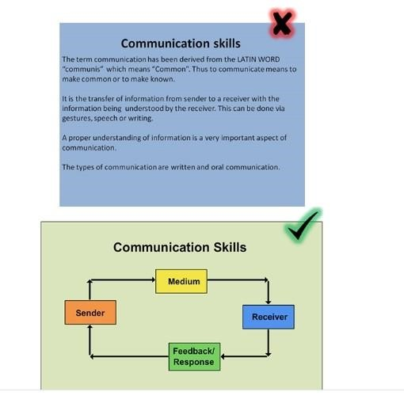

Sounds/animations:

Do not use unnecessary sounds and animation in between the ppt.

These are the direction and may lead to confusion in understanding the topic.

Preparation before the presentation:

Make an effective presentation

:

•

Decide whether to use a podium or walk around.

•

If it is a large audience and a big place a microphone will be needed.

•

Check the working of the mirophone. preferable use a collar mike.

•

Make sure you are formally dressed.

